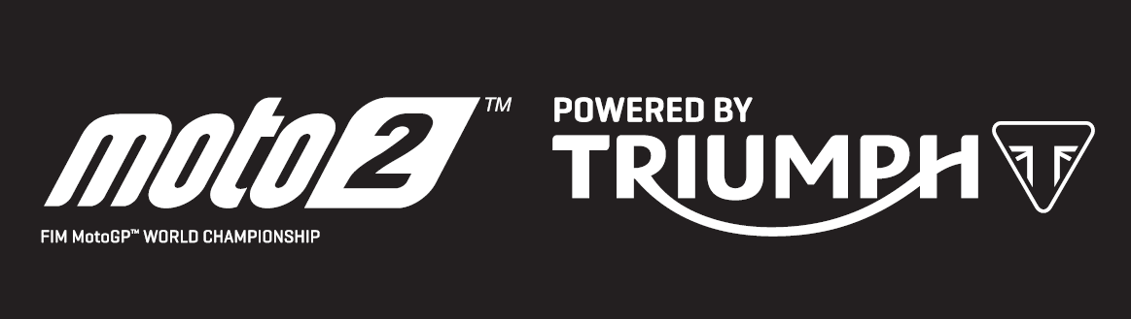

PRESS RELEASE

Lorenzo Baldassarri secures race double as Triumph powers Moto2™ to yet more new lap records in Argentina

The second round of the 2019 Moto2™ Championship in Argentina was another thrilling race with yet more lap records falling to Triumph 765cc power, this time at the Termas de Rio Hondo circuit, following the clean sweep of lap and race records set at the inaugural round in Qatar, three weeks ago.

In the qualifying session the times were incredibly close with the top four inside the all-time lap record set by Johann Zarco in 2015, and the top 22 separated by less than a second. That pace carried into Sunday’s race, where remarkably the top 19 finishers were all faster than last year’s race-winning time in similar dry conditions:

- New Pole Position Record – Xavi Vierge with a 1m 42.726
- Circuit Best lap – Marcel Schrotter with a 1m 42.693
- 2019 race-winning time, Lorenzo Baldassarri - 51.5seconds faster than in 2018,
- All top 19 riders all faster than last year’s winning race time
Qatar-winner and championship leader Lorenzo Baldassarri started from the third grid row in eighth position but wasted no time in fighting through the field, rising to fourth on the opening lap.

Such was the closeness of the pack though, it was lap 19 before he could finally make his way past Remy Gardner (who set the fastest race lap) for the lead. Gardner led for 14 of the 23 laps with Marcel Schrotter also taking his turn at leading five laps, but it was Baldassarri who came to the fore to lead the final four laps to take the flag and extend his championship lead.

Steve Sargent, Triumph’s Chief Product Officer, said: “We couldn’t have asked for more from the opening two rounds of Triumph’s first season powering Moto2™ – again this weekend we saw some incredibly close racing and remarkable performances to set new circuit records in Argentina as well as Qatar. We’re very proud of the performance of our engines, and the fact that the top 19 were all faster than last year’s race-winning time in Argentina demonstrates how much more useable power our 765cc engines offer the riders this year.”

The Triumph Moto2™ 765cc race engine is a development of the class-leading Street Triple RS 765cc road motorcycle and produces more than 140ps and the same visceral soundtrack.

Watch out for more thrilling, hard-fought action at the Grand Prix of the Americas, as Moto2™ moves to the Texas, USA. Race day is Sunday 14th April.

#PoweredByTriumph #TriumphOfficial

ENDS

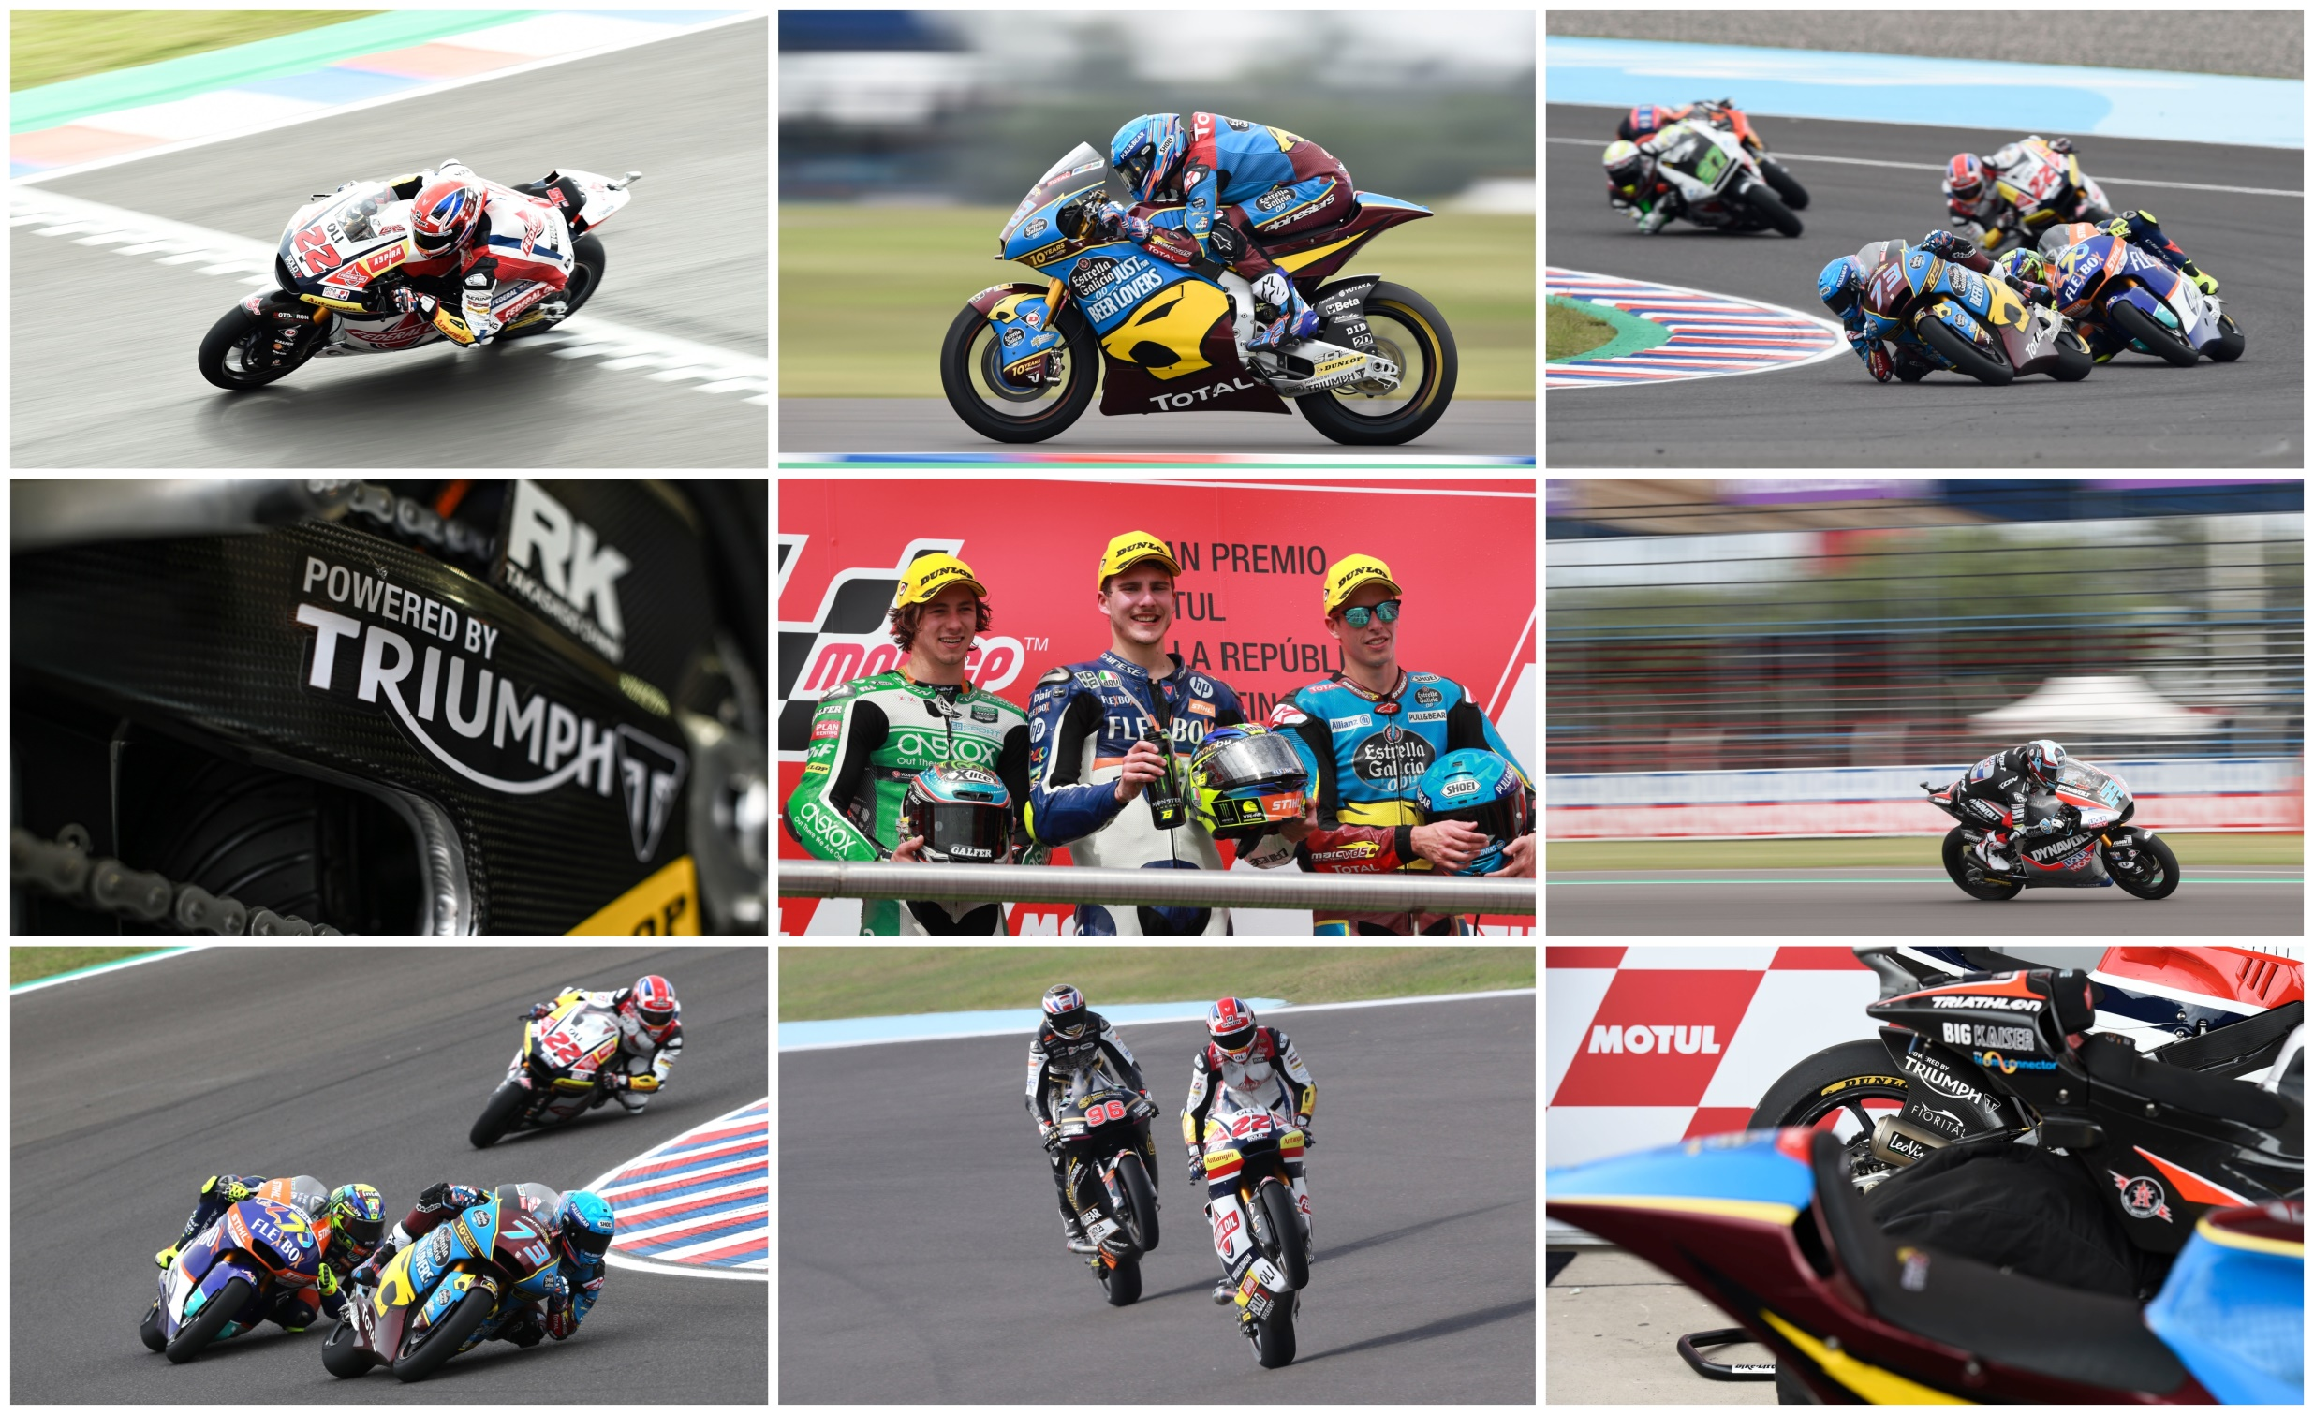

Notes to Editors
About Triumph
- The Triumph Moto2™ 765cc race engine is a development of the class-leading Street Triple RS 765cc road motorcycle and producing more than 140ps and the same visceral soundtrack.
- First established in 1902, Triumph Motorcycles celebrated 110 years of motorcycle manufacture in 2012. For more than two decades, Triumph Motorcycles has been based in Hinckley, Leicestershire, and has produced iconic bikes that perfectly blend authentic design, character, charisma and performance.

- Building around 65,000 bikes per year, Triumph is the largest British motorcycle manufacturer and has around 620 dealers across the world.

- This focus, innovation and engineering passion has today created a broad range of bikes suited to all motorcycle riders, including the iconic new Scrambler 1200, epic Speed Triple, the game changing all new Street Triple 765, the class defining Tiger 800, transcontinental Tiger 1200, iconic Triumph Bonneville family including the stunning Speed Twin, Bonneville Bobber, legendary Thruxton, accessible Street Twin, Street Scramble and iconic Bonneville T120 and T100, plus an exciting and accessible A2 range of Triumph motorcycles

- Triumph currently employs around 2,000 personnel worldwide and has subsidiary operations in the UK, North America, France, Germany, Spain, Italy, Japan, Sweden (Scandinavia), Benelux, Brazil, India and Thailand as well as a network of independent distributors. Triumph has manufacturing facilities in Hinckley, Leicestershire, and Thailand plus CKD facilities in Brazil and India.

- The Triumph Bonneville, famously named to celebrate Triumph’s 1956 land speed record on the Bonneville Salt Flats in Utah, USA, was the original British superbike and a race-winner straight out of the crate. Chosen by famous motorcyclists of the past for its legendary handling, style, and character. It’s that handling, character and style, married to modern rider-focused technology that makes the new Bonneville family THE authentic modern classic choice today.

- Triumph has a glorious racing history, competing in and winning races in almost every class and field of motorcycle sporting achievement. From winning the second ever Isle of Man TT in 1908, through to 1960s road and track domination in Europe and America, right up to contemporary racing achievements with the 675cc Triumph triple powered 2014 Daytona 200 win, the 2014 Isle of Man Supersports TT, 2014 and 2015 British Supersports titles and World SuperSport racing. And now with the new generation of 765cc triple engine powering the 2019 Moto2™ championship, Triumph’s racing legend continues.

